20101524 Reg. No………………….……...

Name……………………………

B.A. DEGREE (C.B.C.S) EXAMINATION, FEBRUARY 2021
Second Semester
B.A. Visual Communication
FUNDAMENTALS OF ANIMATION

Time : Two Hours Maximum : 80 Marks
(50 + 30 = 80)
Part A
Answer any FIVE of the following
- Briefly explain the stages of Cel Animation.
- What is Stop Motion Animation? Write the different techniques of Stop Motion Animation with examples of each.
- What do you mean by CGI? List out the steps involved in the production process of a 3D animated film? Give One example of a 3D animated movie.
- Who was Eadweard Muybridge? Briefly explain his Contributions.
- Write short notes on the following -
  - Persistence of Vision
  - What is Timing and Spacing
  - Anime and Manga
- What is Storyboarding? Mention its importance in making an animated film.
- What are the early animation devices.Diffrentiate between Phenakistiscope and Praxinoscope
- Discuss the importance of camera angles and camera movements in animated films.
(5 x 6 = 30)

Part A
Answer any ONE of the following
- Draw any 5 action poses of your choice.
- Draw 10 facial expressions of your choice.
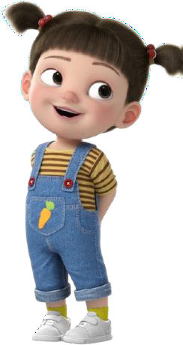

11. Draw any 10 props that can be used by the following
character -

(1 x 20 = 20)

2110324 Reg. No………………….……...

Name……………………………

B.A. DEGREE (C.B.C.S) EXAMINATION, DECEMBER 2021
Second Semester
B.A. Visual Communication
FUNDAMENTALS OF ANIMATION

Time : Two Hours Maximum : 80 Marks (30 + 50)

SECTION A
Answer any Five of the following
- Briefly explain the stages of Classical Animation. Give an example of a 3D animated movie.
- What is Stop Motion Animation? Write the different techniques of Stop Motion Animation with examples of each.
- What do you mean by CGI? List out the steps involved in the production process of a 3D animated film? Give an example of a 3D animated movie.
- Who were Leonardo da Vinci and Eadweard Muybridge ? Briefly explain their Contributions.
- Write short notes on the following -
Time-lapse and Stop motion Animation technique
Praxinoscope and Phenakistiscope
Aspect Ratio and Peg System
6. Discuss the importance of camera angles in creating dramatic effects in animated films.
7. Who was Winsor Mccay? Explain his contributions in animation.
8. Write briefly any 6 principles of animation with examples.
(5 x 6 = 30)
SECTION B
Answer any One of the following
9. Draw any 5 action poses of your choice.
10. Draw 10 facial expressions of your choice.
11. Draw any 10 props that can be used by the following character -
(1 x 20 = 20)

