21102225 Reg. No………………….……...

Name……………………………

B.A. DEGREE (C.B.C.S) EXAMINATION, DECEMBER 2021
Second Semester
B.A. Animation & Visual Effects
CHARACTER DESIGN FOR ANIMATION

Time : Five Hours Maximum : 80 Marks

Part A
Attend any one of the following.

1. Develop a cute Animal character and explain about the character.
2. Create an Animation Character step by step?

3. How to Draw the front and side view of the human head?
(2 x 15 = 30)
Part B
4. Briefly describe the construction of character’s personality using triangle, with your
own examples.

5. Draw five different action poses of the character given below.

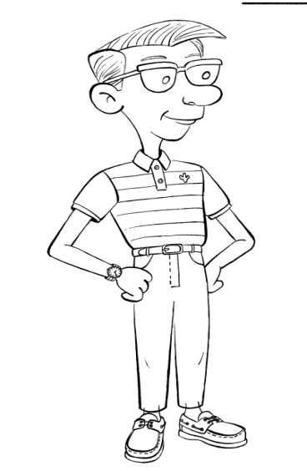
( 2 x 25 = 50 )

