23003331 Reg. No………………….……...
Name……………………………

B.A. DEGREE (C.B.C.S) EXAMINATION, JANUARY 2023
Third Semester
B.A. Animation & Graphic Design
CHARACTER DESIGNING FOR ANIMATION
Question Paper I (3 hrs. duration and 50 marks)
Total Duration: Five Hours Maximum: 80 Marks
(3 Hrs.+ 2 Hrs.) (50 Marks + 30 Marks)
(This examination will have two question papers; Question Paper I and II. Question Paper I has 2 parts, Part A and Part B. Question Paper I will be of 3 hrs. duration and 50 marks. Question Paper II, containing Part C, will be of 2 hrs. duration and 30 marks. Examination using Question Papers I and II will be conducted separately.)
Part A
Attend any two of the following questions.
- Design a heavy pugnacious villain character. It can be a human or an animal.
- Develop a super hero animal character.
3. Create a superhero Human character having some supernatural power

(2 x 10 = 20)
Part B
Attend any two of the following questions.
4. Create a superhero character named ‘Ratman’ in Indian-style.
5. Design a fantasy character using body parts of animals, birds and reptiles.
6. Draw the front view of a proper ideal male figure with anatomy and label its proportions.
(2 x 15 = 30)

23003331 Reg. No………………….……...
Name……………………………

B.A. DEGREE (C.B.C.S) EXAMINATION, JANUARY 2023
Third Semester
B.A. Animation & Graphic Design
CHARACTER DESIGNING FOR ANIMATION
Question Paper II (2 hrs. duration and 30 marks)
( 2 Hrs.) ( 30 Marks)
Part C
Attend any two of the following questions.
7. Create a character who has a dual role ie; the character is an auto driver during day
time, he/she gets power during night and fights against all corruptions in society.
8. Design a super Woman character with action poses.
9. Draw five different action poses of the character given below.

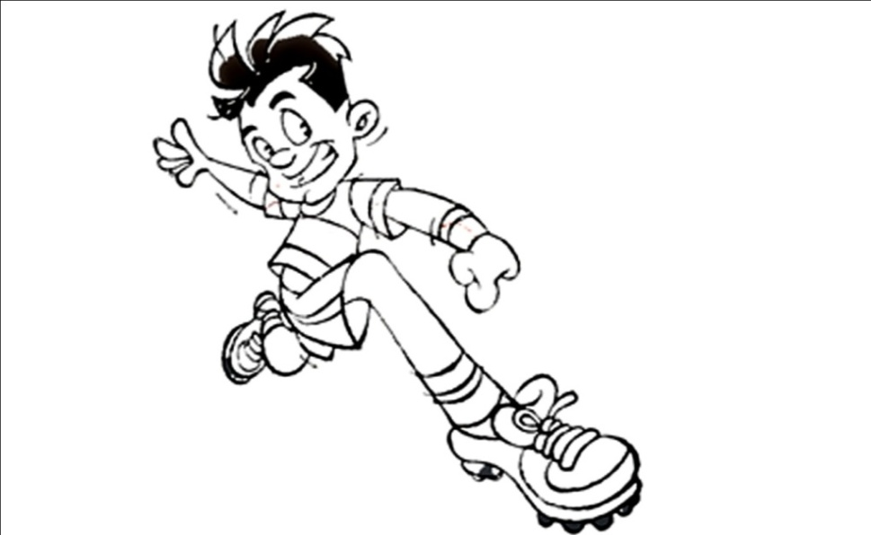

(2 x 15 = 30)

