23103331 Reg. No………………….……...
Name……………………………
B.A. DEGREE (C.B.C.S) EXAMINATION, JANUARY 2023.
Third Semester
B.A. Animation & Graphic Design
CHARACTER DESIGNING FOR ANIMATION
Question Paper I (3 hrs. duration and 50 marks)
Total Duration: Five Hours Maximum: 80 Marks
(3 Hrs.+ 2 Hrs.) (50 Marks + 30 Marks)
(This examination will have two question papers; Question Paper I and II. Question Paper I has 2 parts, Part A and Part B. Question Paper I will be of 3 hrs. duration and 50 marks. Question Paper II, containing Part C, will be of 2 hrs. duration and 30 marks. Examination using Question Papers I and II will be conducted separately.)
Part A
Attend any two of the following questions.

- Draw the front view of a Male figure with proper anatomy and mark its proportions in heads?
- Draw human hand from 5 different angles?
- Draw human face and mark its proportions in heads and ½ heads?
(2 × 15 = 30 Marks)
Part B
Attend any two of the following questions.
- Draw any four-legged animal with appropriate action pose?
- Design a bird character using the basic construction method?
- Draw the following facial expressions for the character given below.
  - Shy b. Angry c. Tired d. Fear e. Happy
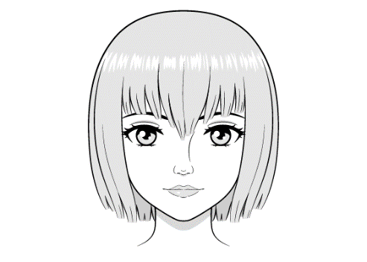
(2 × 10 = 20 Marks)
23103331 Reg. No………………….……...
Name……………………………

B.A. DEGREE (C.B.C.S) EXAMINATION, JANUARY 2023.
Third Semester
B.A. Animation & Graphic Design
CHARACTER DESIGNING FOR ANIMATION

Question Paper II (2 hrs. duration and 30 marks)
(2 Hrs.) (30 Marks)
Part C
Answer any two of the following questions.

- Design a Heavy Pugnacious villain character and write down its features?
- Develop a Cute hero character. It can be human or animal. Write down its features also?
- Design a fairy tale character. Explain the procedure in minimum 5 steps?

(2 × 15 = 30 Marks)

