23114844 Reg. No………………….……...
Name……………………………

B.A. DEGREE (C.B.C.S) EXAMINATION, MAY 2023
Fourth Semester
Visual Arts
Auto CAD II
Time:5 Hrs. Total Marks: 80
Attend any One from the following questions

- Model the given plan in to 3D with exteriors like compound, compound wall, yard and render in JPEG format. Give suitable textures and lighting.
or

- Design the interior of a living and dining room plan given below. the two rooms contains minimum 8 furniture. Give texture and lighting. Render in JPEG format.
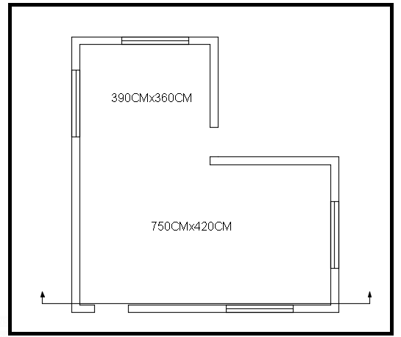

(1 x 80 = 80)

