21101345 Reg. No………………….……...
Name……………………………

B.A. DEGREE (C.B.C.S) EXAMINATION, OCTOBER 2021
Fourth Semester
Animation & Graphic Design
TECHNIQUES OF 3D ANIMATION
Time: 5 Hrs. Total Marks: 80
Attend any One of the following Questions

- Create any one of the cartoon character with correct mesh flow using the reference images.
Produce 2 camera angles for output

- Apply a hand rig include fingers controls and do an animation of hand & ball
Interaction

- Let the sitting character to get up and walk four steps forward..
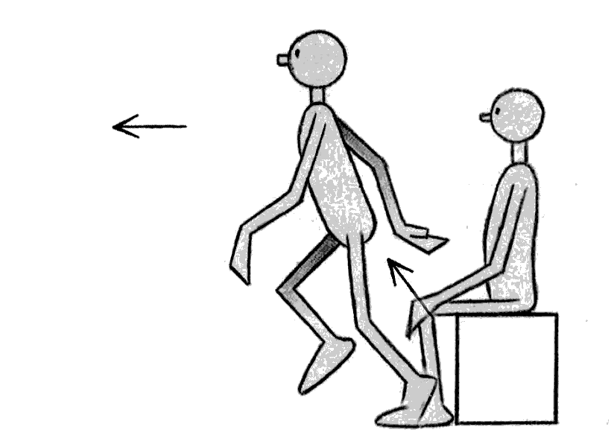
(1x 80 = 80)

