19101454 Reg. No………………….……...
Name……………………………
B.A. DEGREE (C.B.C.S) EXAMINATION, OCTOBER 2019
Fifth Semester
B A Animation & Graphic Design
ADVANCED 3 D ANIMATION TECHNIQUES
Time: 5 Hrs. Total Marks: 80

- Model anyone of the given blue print with proper topology.

- Rig the given character properly. The Rig must have Finger Attributes,
IK Controls, Foot and Shoulder controls.

- Animate anyone of the given Storyboard.
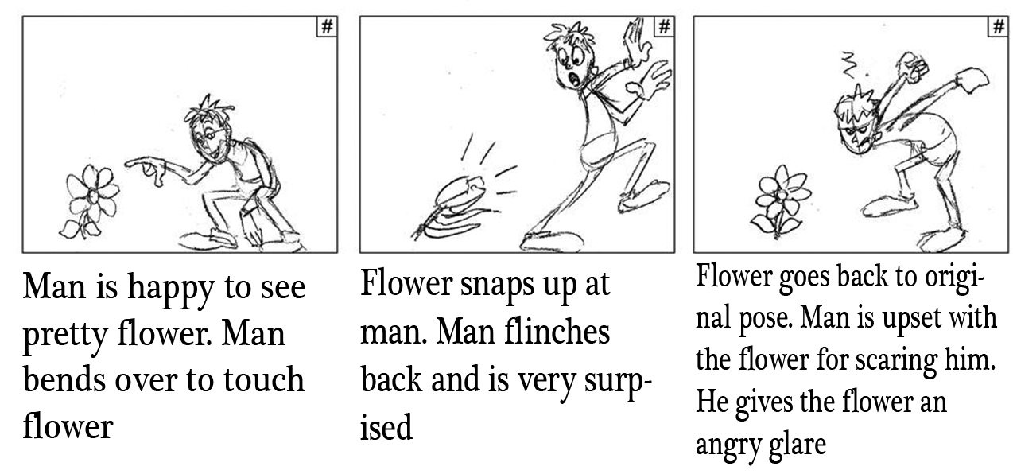
OR
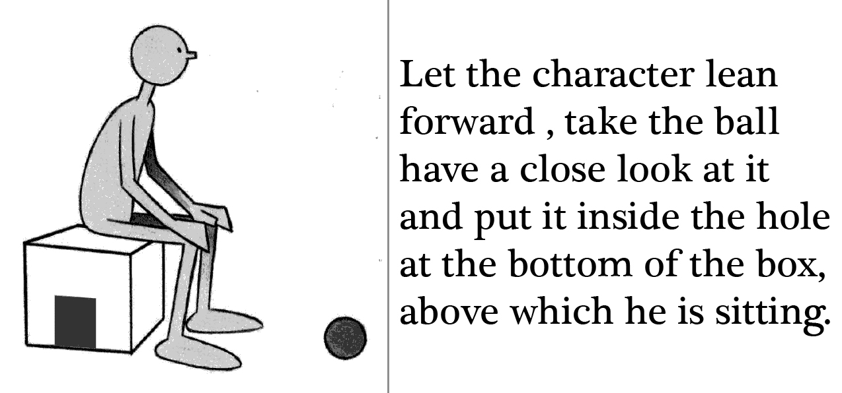 (1 x 80 = 80)

19101454 Reg. No………………….……...
Name……………………………
B.A. DEGREE (C.B.C.S) EXAMINATION, OCTOBER 2019
Fifth Semester
B A Animation & Graphic Design
ADVANCED 3 D ANIMATION TECHNIQUES
Time: 5 Hrs. Total Marks: 80

Answer any ONE from the following questions

- Create a cartoon character with correct mesh flow using the reference images. Produce 2 camera angles for output.

- Model the given body part with all details. Make two camera angle outputs for valuation.

- Rig the given character with all possible controls and attributes. Submit the work file for evaluation.

- Animate the given story line using the supplied rig. Play blast your work for submission.

(1 x 80 = 80)

